Network and Its Types

What is a Network
A computer network is a system where two or more computers are connected to share data, resources, and information.
Key Benefits:
Resource sharing (printers, files, internet)
Communication (email, video calls, chat)
Data storage and backup

Networks can be classified based on size, connection mode and topology:

Types of Networks by Size
a) LAN (Local Area Network) :
Definition: Connects computers in a small area, like a home, office, or school.
Characteristics: High speed
Limited range (usually <1 km)
Usually private
Example: Office network with 10 computers sharing a printer.
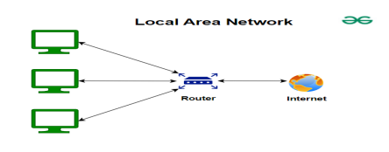
b) WAN (Wide Area Network)
Definition: Covers a large area, connecting multiple LANs.
Characteristics: Low to medium speed
Can be public or private
Uses routers and internet connections
Example: Internet, or a company connecting offices in different cities.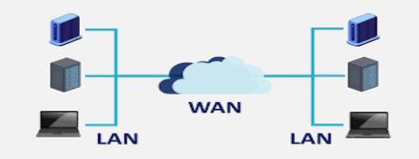

c) MAN (Metropolitan Area Network)
Definition: Covers a city or town, larger than LAN but smaller than WAN.
Characteristics: Medium speed
Connects multiple LANs
Example: City-wide Wi-Fi network.
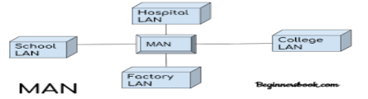

Types of Networks by Connection Mode

a) Wired Network

Definition: Devices are connected using cables (Ethernet, fiber).
Pros: Stable, high speed
Cons: Limited mobility, expensive to install

b) Wireless Network
Definition: Devices are connected using Wi-Fi, Bluetooth, or radio signals.
Pros: Mobility, easy to set up
Cons: Less secure, can be slower
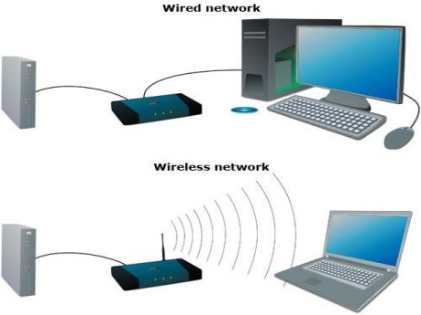

Types of Networks by Topology
Topology is how devices are arranged physically or logically in a network:

1. Bus Topology: Single cable connects all devices.


2. Star Topology: All devices connect to a central hub. 

3. Ring Topology: Devices connected in a circular path.
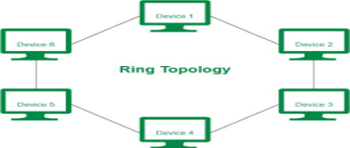

4. Mesh Topology: Devices interconnected, provides redundancy. 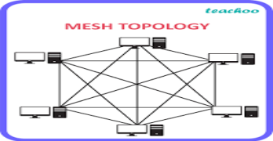

5. Hybrid Topology: Combination of two or more topologies.
